Annex 1: prototype description form
Prototype title: CCF-SymbolWriter
Developer(s): FPD, SU-DART.
Relevant WP: 2.2 2.3
Relevant Activities of the WP: A2.2.4 A2.2.5 A2.3.2 A2.3.3
Relevant Deliverable(s) to be (finally) reported: ID2.2.1 ID2.3.1 ID2.3.2
Relevant Use Cases (mention specific titles from D1.1.3):
4.10 Graphical Symbol Support for facilitated text comprehension and production in OpenOffice.org
Aim of the prototype: To make the text based environment of a standard Office application suite – OpenOffice.org (OO.org) – accessible as a productive tool also for users with more profound problems in relation to text – both in terms of writing and reading. This will be achieved by – in addition to text-to-speech reading support – providing graphical symbol support. Graphic symbols will illustrate the meaning of the words as they are entered into the text, or when text content is loaded from a file. Two main modes for the symbol display will be supported; a) symbol display outside of text in a side window, b) insertion of symbols above the words, together with CCF metadata into the text content. In this mode the symbols will be represented in black and white only, in the format of a private area Unicode font, and as a co called Ruby Annotation element.
Technologies deployed: CCF-SymbolServer, LibreOffice/OpenOffice extension (UNO - Universal Network Objects), Concept Coding Framework (CCF), Java and Java DB-Derby, RDF, Ruby Annotation, OpenOffice.org v.3.2+ and LibreOffice v.3.3+
Available languages: English, Swedish, Spanish, Dutch
Available symbol systems: Blissymbolics, ARASAAC
Major optimisation held for the 3rd phase:
- Re-populated databases with Spanish and Dutch language support added and more efficient database look-up.
- The document's language setting sets the current language used for the CCF word-to-concept-to-symbol look-up.
- Option to install and run the CCF-SymbolServer as an automatically started system service. CCF-SymbolServer window on top and cursor following options added.
- Simplified menu commands and settings management.
- Commands added to control the symbol size.
- Improved focus handling; focus is set directly when placing the cursor by clicking on a word (not requiring a cursor movement in the text – as before).
- Improved functionality for selecting preferred symbol representation when several alternatives are offered – either by pointing and clicking on the preferred symbol in the CCF-SymbolServer window, or by stepping through the alternatives using a keyboard shortcut. Ctrl/Cmd+G is default (as before), but now with an option to define an alternative shortcut key combination if the default one is not available in a language environment.

Short functional description of the prototype (including User Interface, as perceived from the User Point of view):
The current version of CCF-SymbolWriter for LibreOffice/OpenOffice consists of two main parts:
1) the CCF-SymbolServer service application (with its language and symbol database and symbol font file resources), and
2) the CCF-SymbolWriter extension for LibreOffice/OpenOffice Writer.
It all comes as a CCF-SymbolWriter.msi install package for Windows or, alternatively, a zipped file directory for other operating systems. It is (in principle) available for all platforms where LibreOffice/OpenOffice is supported, though only well tested for the Windows (XP+) and MacOS X platforms. It is recommended that the extension is set up for only one user, and run under an admin account (applicable for Windows) to ensure functionality. We will refer to the Windows environment in the following.
After the installation of the CCF-SymbolWriter.msi, a new ccf entry should be found in the Windows system's Start – Programs menu. The content is shown below in Illustration 1. It specifically shows the “CCF Symbol Resources” folder, which contains the additional resources that have to be manually installed before the CCF-SymbolWriter extension is fully operational; contained in the “Font files” and “Install Open Office Addon” sub folders:
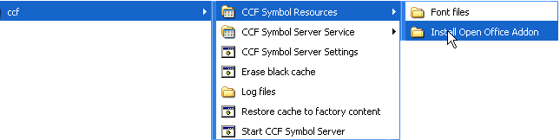Illustration 1: The CCF Start Menu content on Windows
Illustration 2 below shows the content of
- the “Font files” folder (to the left) with the two private area Unicode font files - CCFF1bliss.otf and CCFF1arasaac.otf - providing the Blissymbol and ARASAAC symbol libraries for display within/above text in Writer. These need to be copied or installed into the Windows – Fonts folder on the system (typically C:\Windows\Fonts). (On Windows 7 you can click on them and press the Install button in the window just opened.)
- the “Install Open Office Addon” folder, where the CCF-SymbolWriter extension file - CCF-SymbolWriter.oxt - is found. When this file is double clicked, the user will be prompted about installing this extension into LibreOffice/OpenOffice by the Extension Manager.
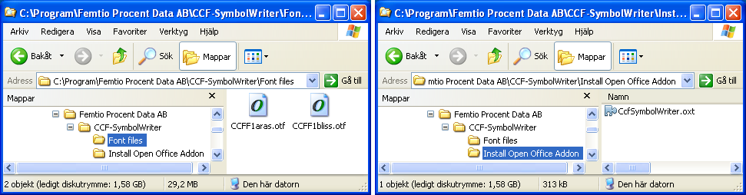Illustration 2: CCF Symbol Resources sub folders
When the CCF extension is registered, and LibreOffice/OpenOffice Writer has been re-started, a new “ConceptCoding” menu item, and a ToolBar button field have been added to the interface. They both contain the following six corresponding items; “View only mode”/”View”, “Symbol insert mode”/“Insert”, “Scan whole document”/“Scan”, “Bigger symbols”/”Bigger”, “Smaller symbols”/”Smaller” and “Turn off CCF symbol lookup”/”CCF-off” – see the screen snapshot in Illustration 3 below.
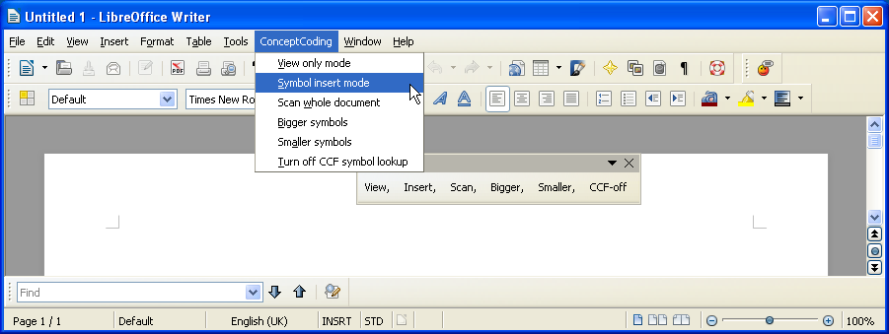Illustration 3: Concept Coding Menu and Toolbar options
By selecting either “View only mode”/”View” or “Symbol insert mode”/”Insert” each word is looked up by the CCF-SymbolServer as you type text into your document, through the Concept Coding Framework (CCF) databases, to find (a) corresponding concept(s) and concept code(s) and respective symbol representation(s) for each word. Each time the space character is hit, the extension sends the word to the CCF-SymbolServer that looks up the concept(s) and symbol(s) representing the word according to your settings – see the screen snapshot image below.
By selecting “Turn off CCF symbol lookup”/”CCF-off” the concept and symbol lookup is halted. The “Scan whole document” option allows you to perform the symbol lookup and insertion in one go for all text in a document. The remaining “Bigger symbols”/”Bigger”, “Smaller symbols”/”Smaller” menu items and Toolbar buttons allow the user to set an appropriate symbol size – both for the symbol fonts presenting symbols inserted into the text, and for the symbols in the CCF-SymbolServer window (Note; that the CCF-SymbolServer display is not updated until the next lookup is made.).
Note; that the on/off state of the CCF symbol lookup is set per document, and is indicated in the CCF-SymbolServer window – either on in View or Insert mode, or off!
Settings are found under Tools → Options → LibreOffice/OpenOffice.org Writer → CCF-SymbolWriter Options. An English installation displays the dialog shown in Illustration 4 below.
The extension is also localized for Swedish at this point, Spanish and Dutch to follow.
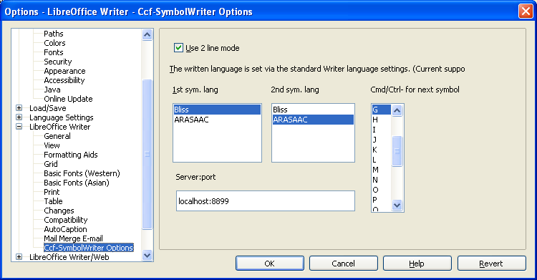Illustration 4: CCF-SymbolWriter Options dialog

The settings options are:
- “Use 2 line mode” – will, if on (default), insert the first found symbol for a word in a so called “Ruby Annotation” field above the word (in a black and white font format). If this option is turned off, all found symbols for each word will be inserted before the corresponding words. This option may in some cases be preferred by teachers, therapists and other facilitators for producing educational material with full colour standard symbol graphics and free layout options.
- The remark about “Written language” setting, deciding which of the available text lookup languages to use (currently English, Swedish, Spanish and Dutch), states that this is following the current general language setting of the document (for the current paragraph).
- 1st sym. lang and 2nd sym. lang options, which select which symbol set, Blissymbolics or ARASAAC, to use as primary and secondary representation. If a word does not have a representation in the primary symbol set, the plugin will look for a representation in the secondary and, if found, display it. If only one representation is wanted, the same symbol representation may be selected in both lists. Words that do not have a matching representation in either set will appear as text only.
- The Ctrl+key (Cmd+key) for next symbol setting allows the user to select a shortcut key other than the default Ctrl+G (Cmd+G) for choosing another among available symbol representation alternatives
- The “Server:port” is displaying the port setting for the communication between the OO.org extension and the CCF Symbol Server.

The default settings after installation is as shown in the settings dialog above.
Note; that when “2 line mode” (Ruby Annotation mode) is on, the user may choose between available symbol representations by tapping the Ctrl+G (or other selected) shortcut key, or by selecting the desired symbols directly in the CCF-SymbolServer window! You may also choose to use none of the presented symbol alternatives in this way.
The CCF-SymbolServer and the CCF-SymbolWriter extension handle inflections of words to some extent, but gaps and imperfections will still be found. If a word with an inserted symbol needs to be changed, the whole word must be deleted and re-entered to look up the new word. (This also means that the requested option to change the look-up word under an inserted concept/symbol to a custom one is not yet supported. It is planned for the final version.)
The word-concept-symbol look-up is quite fast for words contained in the pre-cashed vocabulary. When new non-cashed words are looked up, the user will experience a shorter or longer delay during the first look-up (depending on the number of possible concepts and representations connected to it), but after this the word will be included in the cash for future quick retrieval.
Below follows a couple of screen shots from LibreOffice Writer with the CCF-SymbolWriter extension and CCF-SymbolServer in operation with some different settings:

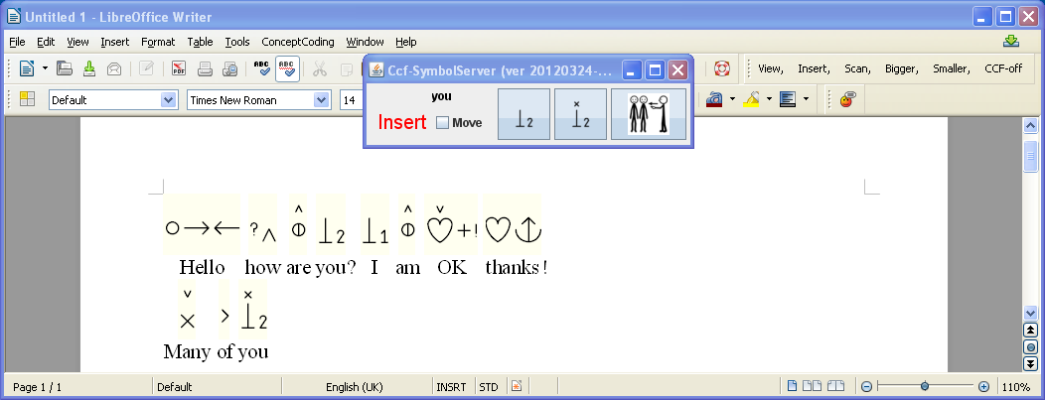Illustration 5: CCF-SymbolServer window floating on top in the upper centre over the LibreOffice Writer window - Blissymbols inserted above text in the 2 line Ruby Annotation format
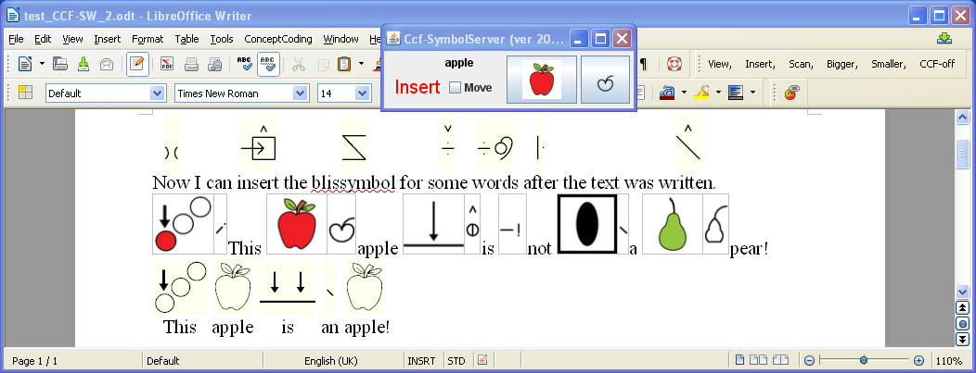Illustration 6: Mixed mode symbol representations (CCF-SymbolServer window floating on top):
- Blissymbols as font above selected words, - ARASAAC and Bliss as graphics within text (2-line mode off in the settings dialog), - ARASAAC as font above text
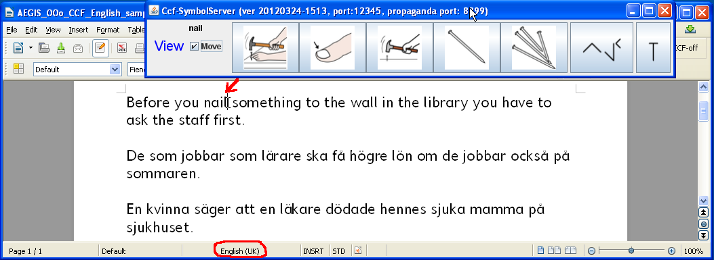Illustration 7: No symbols insertion in text: The CCF-SymbolServer is displaying looked-up concepts and symbols as words are written, and/or as the text cursor is moved within the text, and/or when words are pointed and clicked at – Note; English part of text!
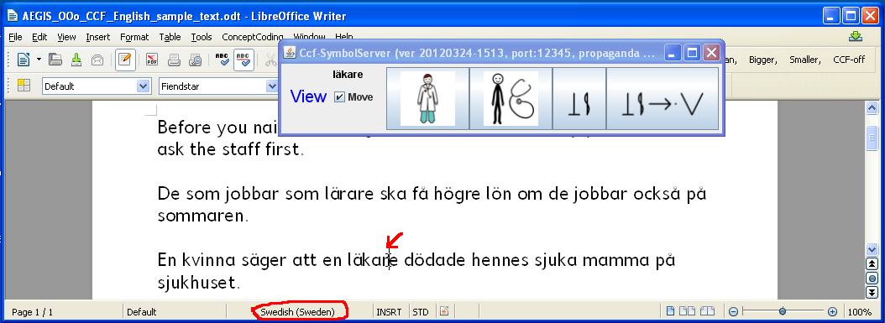Illustration 8: Same text and mode as above (in Illustration 7), but now in the Swedish part of the text. Note that the CCF-SymbolServer is automatically adjusting to the language setting of the text!

Note: If you have a Text-to-Speech tool available on the system – such as ClaroReader or TextHelp – you may use that in combination with the symbol support in a configuration suitable for the individual user. It is recommended to offer this option for a major part of the potential users if possible, especially for those who are used to having TTS support available.
(A free open source TTS solution based on eSpeak and Simple TTS Reader is presented below.)
Limitations, restrictions and dependencies:
- Concept Coding is still not fully matured for the word-to-symbol representation. Thus, the language ontologies are far from complete and error free, which results in unnecessarily many erroneous or odd word-concept-symbol matches, or lack of matches. There is still no handling of multi word concepts (including infinitive verbs constructs such as “to go” etc) or condensed forms like “it's” etc. However, the user may select the most appropriate symbol among those presented – by stepping through the offered alternatives using the Ctrl+G shortcut key command, and now also by clicking on the desired symbol in the CCF-SymbolServer window.
- The Ruby Annotation grouping of symbol above word is now implemented, but the limitations of the Ruby Annotation support in OpenOffice has forced us to use a temporary font based solution for the symbol display. This, for example, does not allow us to display the colour version of the ARASAAC symbol library in the 2-line Ruby Annotation format above words in a text. It should also be noted that this is not the since long envisaged proper Unicode font solution for Blissymbolics (building Bliss words from a limited set of standardised Bliss characters) but a provisional solution.
- The option to have symbol display outside the text is provided via the CCF-SymbolServer window – now optionally displayed on top of other windows (default), and following the text insertion caret at a certain distance above (not by default). This may be started in several alternative modes which are set by running the CCF Symbol Server Settings app:
“Mini” – displaying a horizontal display of minimal size is the default.
“Normal” – also a condensed format but more in the vertical direction (to be placed best at the right-hand-side of the Writer window) – displaying concept definitions with the symbols, and “Verbose” - displaying more detailed information about the concept ID etc. (mostly for inspection of the CCF functionality).
- We can now provide a first available adaptation for creating symbol documents via an on-screen symbol selection set, as described in the use cases. This is currently available only for Bliss in the form of a SAW6 (Special Access to Windows) selection set solution for direct selection, covering around 600 symbol concepts – one for English and one for Swedish.
It outputs/inserts whole words into Writer – with speech support, if a clipboard TTS reader is running. The symbol selection sets are tailored to look up the correct Blissymbol representations in most cases.
See below for a screen snapshot from the SAW selection set arrangement, and more details about how to set up a free and open source system with this and/or TTS support.

Expected delivery time of prototype, ready for evaluation:
Preliminary Beta version: 1 April 2012
Evaluation Beta version: 15 April 2012

The CCF Symbol Support Extension with additional Assistive Technologies (AT)
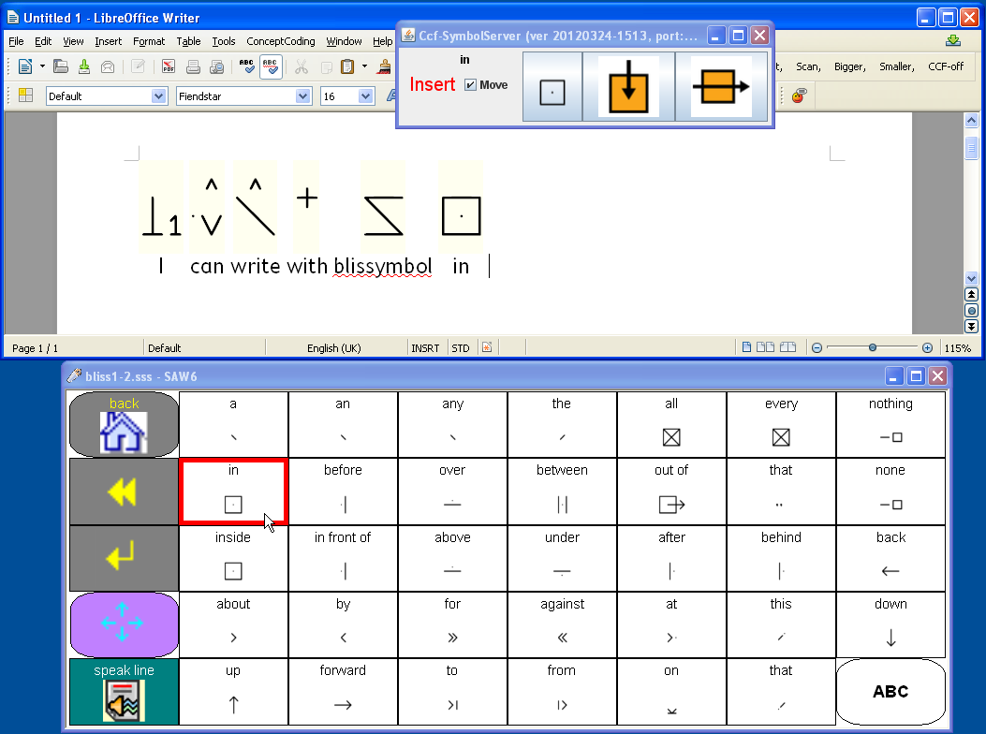Illustration 9: LibreOffice Writer with the CCF Symbol support (Bliss), receiving whole word text input (with adaptation to lookup correct concept and symbol) from a SAW6 (Special Access to Windows) Blissymbol selection set. (This selection set also supports word-by-word and line clipboard reading via the Open Source "Simple TTS Reader" using available MS SAPI TTS voices)
Many of the users who may appreciate the CCF symbol support will also require or benefit from additional AT support, such as Text-To-Speech (TTS) to read the text content, and/or an on-screen keyboard for alternative input via an adapted pointing device or switch controlled scanning.
For AAC users who communicate with graphic symbols and don't read or write, input via an on-screen symbol display will be required.
It is perfectly possible to set up a system meeting these requirements based on the range of existing AT software tools available on the market – in particular for MS Windows, but also for MacOS X. It will unfortunately currently be difficult to achieve this for Linux systems.
In Windows, this can be achieved based on Open Source software tools alone. Here is a suggested set-up:
For TTS support download and install eSpeak from: http://espeak.sourceforge.net/
Also download and install Simple TTS Reader from: http://simplettsreader.sourceforge.net/ .
This latter is a so called “clipboard reader” that can use the eSpeak or other voices to read any text that is copied to the clipboard.
For on-screen symbol or letter based keystroke input, use Special Access to Windows (SAW6), which can be downloaded via: www.oatsoft.org/Software/SpecialAccessToWindows .
More detailed instructions on how to install SAW and the needed additional resources for these purposes are found at: … .
Above is a screen-dump of SAW symbol display used to input text with symbol display in Writer.

© 2010 BCI, www.blissymbolics.org. License: CreativeCommons–BY–SA
© 2010 ARASAAC www.catedu.es/arasaac . License: CreativeCommons – BY–NC–SA

