Annex 1: prototype description form
Prototype title: CCF-SymbolDroid
Developer(s): Farre, Bengt (FPD), Nordberg, Lars (FPD)
Relevant WP: WP4.6
Relevant Activities of the WP: A4.6.3
Relevant Deliverable(s) to be (finally) reported: D4.6.3

Relevant Use Cases

- Primary Use Case:
Symbol-based Augmentative and Alternative Communication (AAC) system for mobile devices for direct person-to-person (face-to-face) communication
- Secondary Use Cases:
Augmentative and Alternative Communication (AAC) for instant and text messaging (IM/SMS) on mobile devices
- Mobile as an AAC device for severe motor and/or speech impairment [for indirect (remote) person to person communication]

Aim of the prototype:
For a facilitator; To be able to create symbol charts for their users and share / load others' charts. For the users, to compose a message and display in face-to-face communication. To send the symbols transformed into text in an SMS is also available, but is just a precursor to the functionality to send and receive messages with symbols which will be in the final release.
For a user; To be able to compose and show / audioplay /send (text of) the message. The user should be able to select pages from different pages and sub pages, and switch between Bliss symbols and ARASACC.

Technologies deployed:
Android SDK, Java, CCF-SymbolServer v1.0.1, Concept Coding Framework (CCF), SQLite,

Available languages:
Buttons are in English for the 3rd Pilot version, vocabularies for the symbols are available in English, Swedish, Dutch and Spanish.

Short functional description of the prototype (including User Interface, as perceived from the User Point of view):
The CCF-SymbolDroid is a digital AAC symbol chart, with interaction options. A chart can range over several pages and sub sections, and a facilitator user can compile their own charts with the symbols of their choice. Charts can be stored, shared and downloaded via the cloud. Once a chart is loaded, the user can compose a message which can then be shown in a person-to-person context or emailed as text. It can also be spoken using TTS.
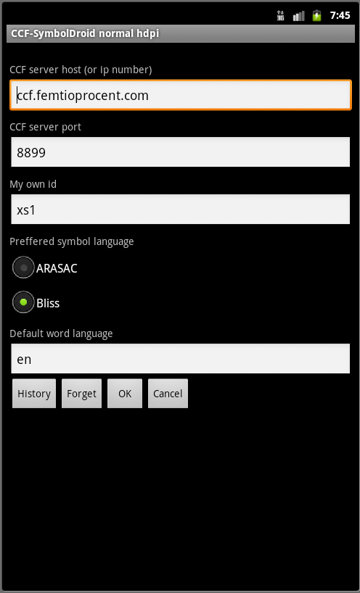Illustration 2: Settings
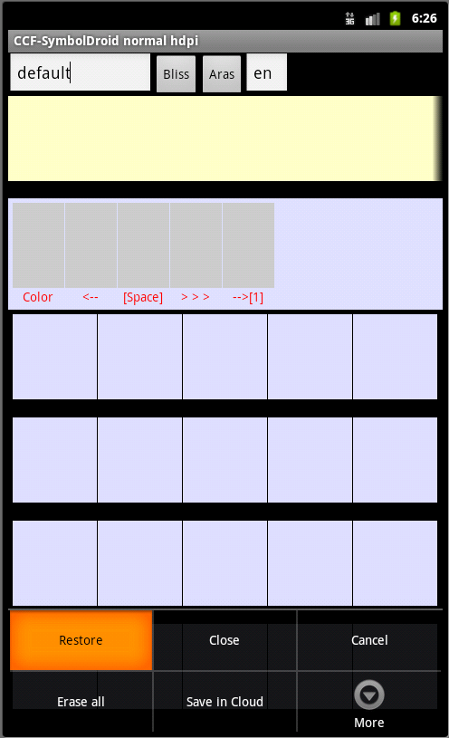Illustration 1: Load a chart called "default" from the cloud

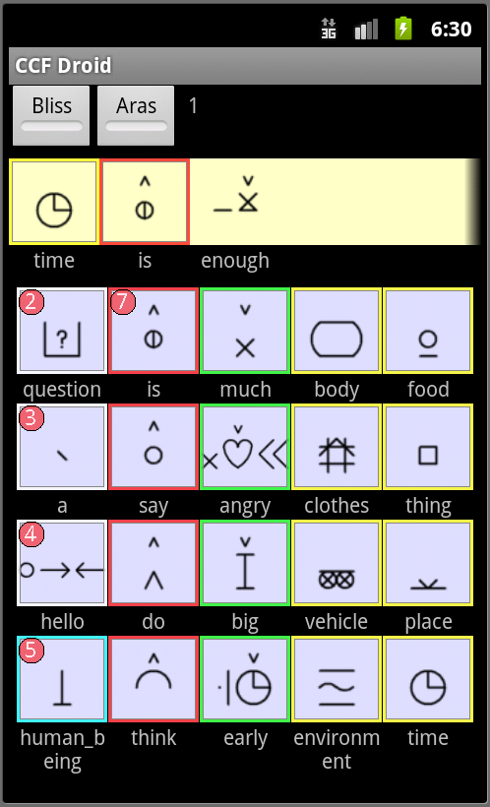Illustration 3: User composing a message from a symbol chart
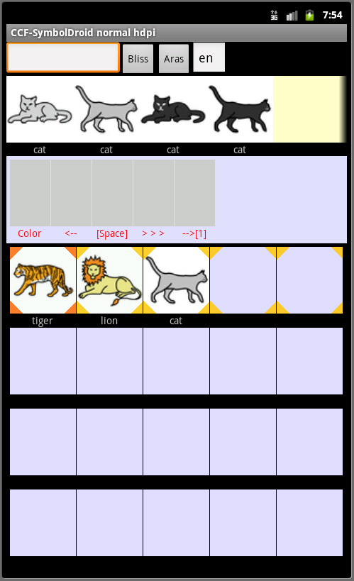Illustration 4: Making a chart with different kinds of felines

Should be evaluated by:
Experts and experienced tutors, mainly with regard to, and together with, users with cognitive impairments, reading disability or language disorder, or users that for other reasons have difficulty processing text. Mode of evaluation: with observation of users and evaluation based on questionnaire.

Research Hypothesis for the 3rd Phase (1-2 sentences):
Facilitator users can create maps with sub pages and a mix of Bliss and ARASAAC symbols (or either). The maps can be created through searching in each of the supported languages.
Users can find and use the concepts needed in the preloaded charts. Navigation between pages and switching symbol languages works ok.

Stepwise task scenarios (for users' interaction with your s/w):
Scenario 1: Configure and load symbol maps
- Start CCF-SymbolDroid app.
- Press menu choice “Settings”
- Change the text for “My own id”. Make sure it is unique for each user. You might leave it as it is by default also.
- Change the default word language (sv = swedish, en = english, sp = spanish)
- Press OK
Please note that for speech synthesis, settings are picked from the phone settings.

Scenario 2: Create/Modify Symbol map

- Start CCF-SymbolDroid
- Press menu and select “Edit”
- In the upper left corner write a word in text.
- Change the language in the text box to the right if needed.
- Press “Lookup Bliss” or “Lookup ARASAAC”
- If found, the symbols will be put into the yellow area (scrollable if many)
- press a symbol area on the grid a few times (=2) until it is first marked in light orange and next in dark orange triangular corners.
- Press the symbol found in the lookup.
- The marked area will be replaced with symbol just pressed. (A bug may set the area in black :-( )
- Pressing the grid area will put the text under symbol in the text field in upper left corner.
- Press grey button “>>>” to increase the page indicator on the button to the right.
- If several hits are found for the word searched for, the colours indicate which is the currently selected symbol to be inserted into the map to make. The colour settings are configurable.
- When the map is done, it can be saved in the cloud by going to context menu → Save in Cloud. The user is prompted if they would like to overwrite, and if accepted, the cloud stored map is overwritten with the current map. There is only one set available per user id in this version.
To add pages to a loaded symbol map, just press the context menu and select Edit. Changes made here are stored locally but cannot update the downloaded map in the cloud. Any pages with symbols created next to the loaded chart that are uploaded into the cloud, will be stored under your own id and possible to sync to another device.

Scenario 3: Compose a message and show it / have it spoken
(Provided that maps are available in the app to select from)

- Compose a message by pressing one image at a time, these images then go to the compose message area
- Erase the latest entered symbol by pressing the Erase button.
- Press one of the symbols with red number links on it. They are links to other pages in the app. Then on the next page you arrive at, select one of the symbols and it goes to the compose area. The symbols with red number links on them cannot be inserted.
- When the message is composed and you want to show it to someone, display it in the same manner as it was composed, in portrait or landscape mode.
- To have the message read by TTS, tap in the compose field.

Scenario 4: Send a composed message as plain text via SMS
(Provided that maps are available in the app to select from)

- Write a message using the symbol grid.
- Press menu button and select “Send”
- A new dialogue appears
- Enter the phone number for the recipient if needed
- Press “Send SMS” button to send the text as SMS (carrier will charge money based on their price list).
- If the device is set up to handle email, the text can be emailed. Text messaging and emailing is not considered a mandatory test step.

Limitations/Restrictions/Dependencies:
- The current version is not targeted towards users with visual impairments, and although it is compatible with TTS, it has not been tested together with screen reading software for the user controls. This deliverable has a dependency on A4.6.1, but can in fact function equally well with other TTS software for Android.
- When creating maps, they are stored in the cloud based on the user set under “Settings”. This implies that it is not possible in the pilot version to create several different maps, for instance for different users.
- At map creation, the grid cells sometimes temporarily are black instead of displaying the colour. They are still added and will be loaded when working with the chart.
- Swiping to see the next page can sometimes lead to going down in sub pages instead. Then just tap the home button to go back.
- For the first symbol to add to the chart when making a map, it is necessary to tap in the target cell before tapping the symbol you would like to select. For the following insertions, they are inserted automatically in the next available grid cell.

